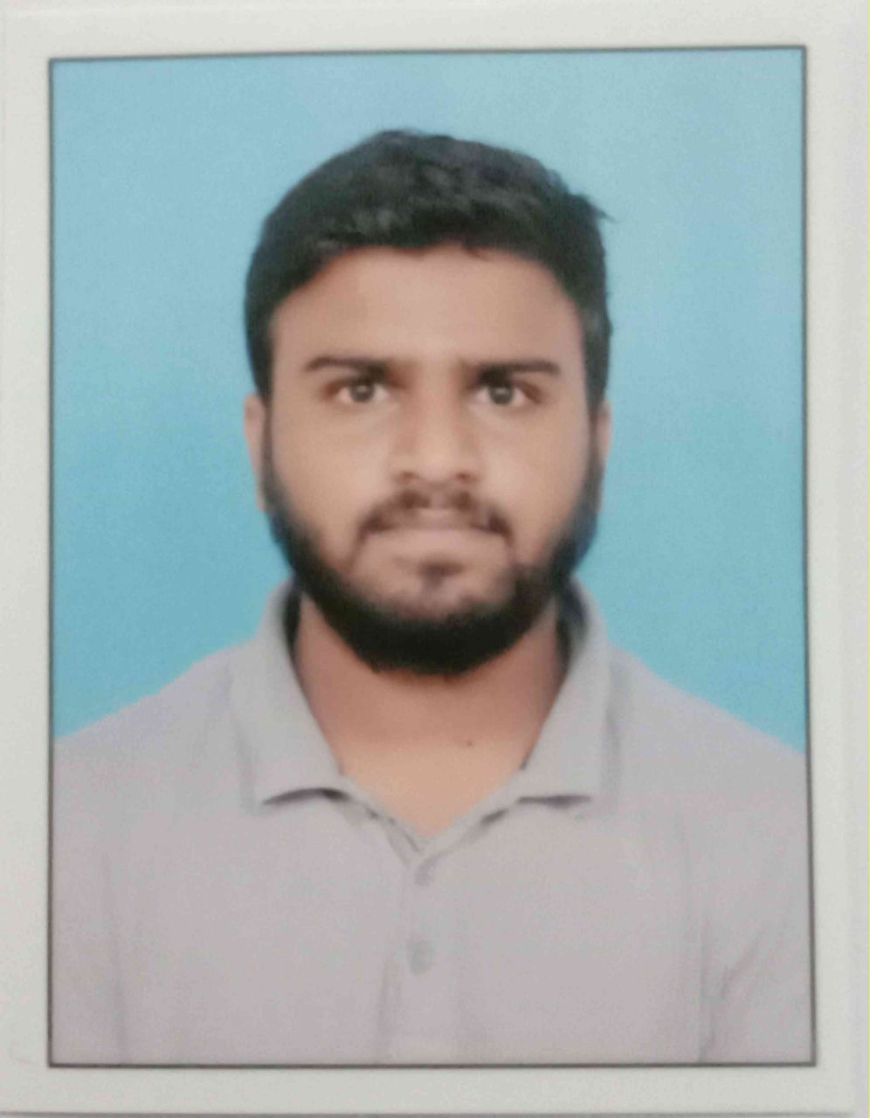
M : +91 7337513385
BUCHUPALLI MOHITHA
CSD Trainee
Summary
To acheive a position in the organization where I can utilize my skills to deliver the project with excellence and open minded to learn new things.
Area of Expertise Industries
• C#
• SQL • Cognizant
• Java
•Python
Work Experience
Role / Work title
Programmer Analyst Trainee
Currently undergoing a training program on Java and SQL programming, including Java basics and Core Java, query writing, and data analysis. Gaining technical knowledge and improve programming skills. Knowledge of SQL database management tool like BODS and Eclipse for Java. Experience in creating, modifying and maintaining SQL scripts and stored procedures.
Education
Graduation : engineering College.
B.Tech ( 2019 - 2023 )
Intermediate : Junior College, , Andhra Pradesh
MPC ( 2017-2019 )
Languages Skills
• Telugu • C++
• English • SQL
• Hindi • Elixir and Erlang
• German
©2023 Cognizant. All rights reserved

